For Each Loop
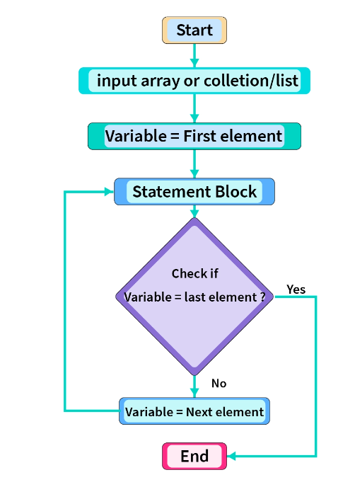

🔁 FOR-EACH LOOP (Enhanced for Loop) – COMPLETE NOTES

1️⃣ What is a for-each loop?
A for-each loop is a special loop in Java used to iterate (traverse) elements sequentially from:
- Arrays
- Collections (List, Set, etc.)
👉 It automatically moves from first element to last element
👉 Programmer does not control index or counter

2️⃣ Why was for-each loop introduced?
Before Java 5:
- Only normal for loop existed
- Code was lengthy and error-prone (index mistakes)
Java introduced for-each loop to:
- Reduce boilerplate code
- Improve readability
- Prevent index-related bugs

3️⃣ Syntax (Very Important)

▶ For Array
for (datatype variable : arrayName) {
// logic
}

▶ For Collection
for (datatype variable : collectionName) {
// logic
}

4️⃣ Meaning of Each Part (Line by Line)
for (int x : arr)
- int → datatype of element
- x → local variable (temporary copy)
- : → read as “from”
- arr → array or collection
📌 Meaning:
For every element x from arr, execute the loop body.

5️⃣ Internal Working of for-each Loop

🔹 For Arrays
✔️ Internally, for-each uses a normal for loop
✔️ It uses:
- a hidden index
- from 0 to length - 1
📌 You don’t see the for loop, but it exists internally.

🔹 For Collections
✔️ Internally, for-each uses an Iterator
✔️ It repeatedly calls:
- hasNext()
- next()
📌 You don’t see the iterator, but it controls the traversal.

🧠 Why this understanding is important
Because it explains:
- why index is not available
- why modification fails
- why ConcurrentModificationException happens
- why for-each is read-only

🏆 Interview-Perfect One-Line Answer
Yes, internally the for-each loop is translated into an index-based for loop for arrays and an Iterator-based loop using hasNext() and next() for collections, with these details intentionally hidden from the programmer.

6️⃣ Flow of Execution (Step-by-Step)
- Control enters loop
- First element is copied into loop variable
- Loop body executes
- JVM automatically moves to next element
- Continues till last element
- Loop exits automatically
📌 No condition
📌 No increment
📌 No index handling by programmer

7️⃣ Key Characteristics (Must Remember)

✔ Sequential Access Only
- Always starts from first element
- Always ends at last element

✔ Forward Direction Only
- Cannot traverse backward
- Cannot skip elements

8️⃣ No Index Access ❌ (Critical Limitation)
In for-each loop:
- Index does NOT exist
- Position cannot be determined
❌ Invalid:
arr[i]
✔️ If index required → use normal for loop

9️⃣ Read-Only Nature (Most Important Concept)
For-each loop provides read-only access.
Example:
int[] arr = {10, 20, 30};

for (int x : arr) {
x = x + 5;
}
❓ Does array change?
👉 ❌ NO
📌 Reason:
- x is a copy of array element
- Original array remains unchanged

🔍 Interview Line
For-each loop variable holds a copy of element, not the actual element.

10.

🔹 Core Concept 1

Method calls are NOT the restriction
for-each loop does not ban method usage.
You are free to call any method inside the loop.
What matters is what the method does, not where it is called.
✔️ If a method only reads data → safe
❌ If a method changes structure → unsafe

Example
for (String s : list) {
System.out.println(list.size()); // ✅ allowed (read-only)
}
📌 Method calls themselves never cause errors.

🔹 Core Concept 2

Structural modification is forbidden
for-each loop internally relies on:
- a hidden index (arrays)
- a hidden iterator (collections)
These mechanisms expect the container to stay unchanged during traversal.
Changing:
- size
- order
- structure
breaks this expectation and leads to runtime failure.

Example
for (String s : list) {
list.remove(s); // ❌ ConcurrentModificationException
}
📌 This is a design safety rule, not a limitation.

Structural Modification – What Exactly Is NOT Allowed in for-each

🔑 First, the Golden Rule (Lock This)
Any operation that changes the structure or traversal order of the collection during a for-each loop is NOT allowed.
The reason:
- for-each uses a hidden Iterator
- Iterator expects the collection to remain structurally stable

❌ Operations that are NOT Allowed (Cause Runtime Error)

1️⃣ Adding elements
list.add("A");
list.add(0, "B");
📌 Changes size → ❌

2️⃣ Removing elements
list.remove("A");
list.remove(0);
list.clear();
📌 Changes size → ❌

3️⃣ Sorting the collection
Collections.sort(list);
list.sort(comparator);
📌 Even if size stays same, order changes
📌 Iterator’s traversal order becomes invalid
❌ Not allowed during for-each
✔️ Sorting must be done before or after iteration

4️⃣ Shuffling / Reordering
Collections.shuffle(list);
Collections.reverse(list);
📌 Traversal order changes → ❌

5️⃣ Replacing entire collection
list = new ArrayList<>();
📌 Loop iterator still refers to old collection
❌ Logical error / unsafe

6️⃣ Bulk structural operations
list.addAll(otherList);
list.removeAll(otherList);
list.retainAll(otherList);
📌 Structure and size change → ❌

⚠️ Important Note (Interview Trap)
Even if:
- method is called using original reference
- or from another method
❌ Still NOT allowed if it modifies structure.
The iterator does not care who modified it.

✅ Operations that ARE Allowed (Safe)

✔ Read-only methods
list.size();
list.contains("A");
list.isEmpty();

1️⃣ set(index, value) – Allowed but not preferred
Core idea
- Replaces one element with another
- List size does not change
- Element position does not change
Snippet
for (String s : list) {
list.set(0, "X"); // ⚠️ allowed, but confusing
}
Conclusion
- Technically allowed
- Logically discouraged inside for-each

2️⃣ Object state change – Allowed and safe
Core idea
- Object state = data inside the object
- Collection shape remains unchanged
Snippet
for (Student s : students) {
s.setMarks(90); // ✅ safe and reflected
}
Conclusion
- Safe
- Intended usage of for-each

3️⃣ Primitive values – Change not reflected
Core idea
- Loop variable gets a copy
- Original array value remains same
Snippet
for (int x : arr) {
x = x + 10; // ❌ not reflected in array
}
Conclusion
- You modify the copy, not the stored value

🧠 MEMORY RULE (Lock This)
Change collection size ❌
Change collection order ❌
Change object data ✅
Change loop variable ❌

🏆 INTERVIEW ONE-LINER
In a for-each loop, the collection itself must not be changed, but modifying the data inside the objects stored in the collection is allowed.

🔒 FINAL LINE
for-each is for reading the collection, not reshaping it.

✔ Is set() allowed inside for-each?
👉 YES, it is allowed if:
- the method does not change
  - collection size
  - collection order
  - collection structure
set(index, value) only replaces an element, so:
- size stays same
- positions stay same
That’s why Java allows it.

⚠️ Why is it NOT encouraged?
Because:
- for-each is meant for reading
- set() is an update operation
- mixing read + update inside for-each hurts readability
- logic becomes confusing in real projects
📌 This is a design and clarity issue, not a technical error.

🔴 Important Clarification (Very Important)
This rule applies to collections (like List) that have set().
❌ Arrays do NOT have set() method
Arrays use index assignment:
arr[0] = 10; // array update
This should NOT be done inside for-each because:
- you don’t have index access
- for-each is not designed for updates

🧠 Final Memory Rule (Perfect)
If a method changes data without changing structure, Java allows it.
But for-each is still meant for reading, so updates are discouraged.

🏆 Interview-Perfect Line
Yes, methods like set() that replace elements without changing the size or order of a collection are technically allowed inside a for-each loop, but they are discouraged because for-each is designed for read-only traversal.

